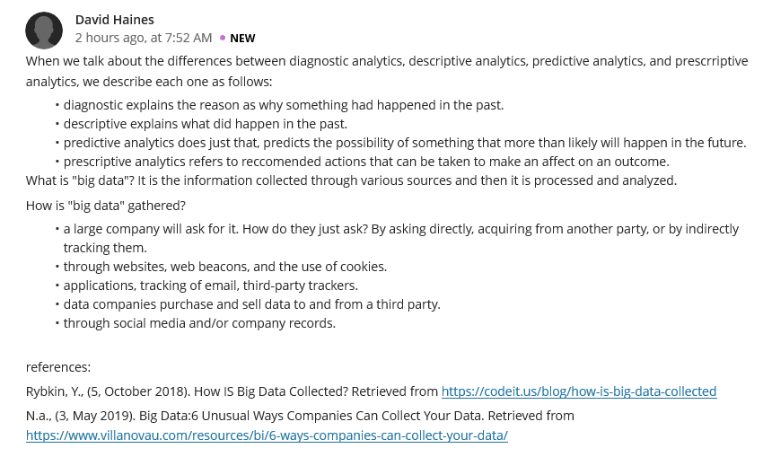
Reply
Diagnostic analytics, descriptive analytics, predictive analytics and prescriptive analytics are the four categories of business analytics that businesses exploit, more importantly, to make the raw data actionable through vigorous analysis. If you want to understand the reason why something happened in the past you use diagnostic and descriptive is utilized to explain what exactly did happened in the past. In addition, predictive analytics is applied to identify core patterns and trends by predicting something possibility that more likely will occur in the future and prescriptive analytics will focus on the suggested informed actions that should be put under consideration and their implications that can be achieved from each. I like the way you have explored on this study, particularly, by defining big data as information generated via several sources and then processed and analyzed which is vital to conduct an effective business analytics. Well enough, organizations can gather big data through various means such as websites, social media, company records as well as applications, and in this light, they can enjoy a competitive advantage in the market by making sound decisions.

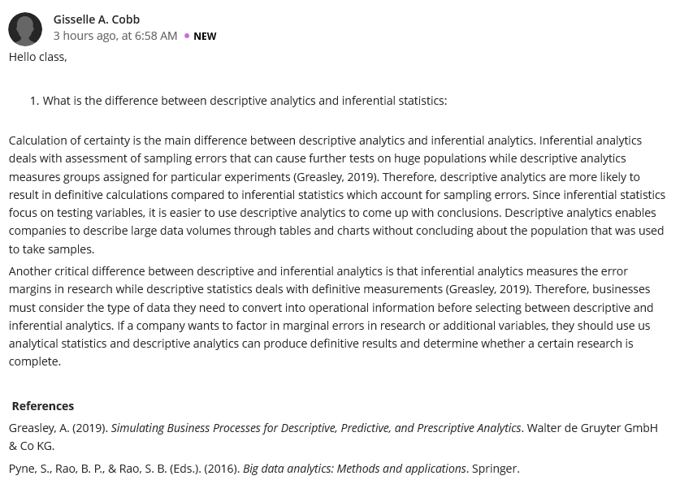
Reply
There is tremendous growth in the global market which has become challenging to the organizations, specifically, in calculating certainty. Luckily, you are trying to fill this gap by identifying the difference between descriptive analytics and inferential statistics. Inferential statistics emphasize on sampling errors assessment that can result to further tests on big populations while descriptive analytics deals with the measurement of groups assigned for a particular experiments. When you use inferential statistics, you should be aware that this approach focuses to test the variables resulting to sampling errors as compared to descriptive analytics which accounts for definitive calculations, suitable for solid conclusions. In this respect, descriptive analytics is pivotal to companies because they have the capacity to use tables and charts in describing large data volume by not necessarily concluding about the population that was utilized to take samples. Besides, inferential analytics is aptly effective in measuring the error margins when conducting research, and on the hand, descriptive statistics is appropriate in definitive measurements. Your study is beneficial to businesses as it motivates them to be more strategic and proactive when converting raw data into actionable insights before incorporating descriptive or inferential analytics.

